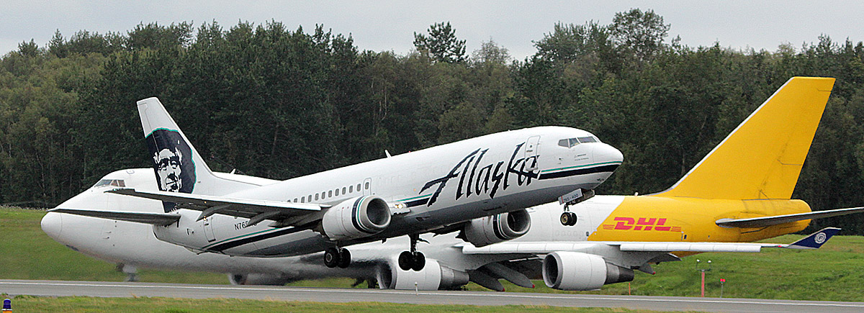
Alaska International Airport System Passenger and Cargo Airline Incentive Program
To promote the expansion or addition of scheduled passenger and cargo airline service at Ted Stevens Anchorage and Fairbanks International Airports, AIAS has developed a Passenger and Cargo Service incentive program with the following categories of eligible service and term and conditions of eligibility for participation. The program is at all times subject to conformance with Federal Aviation Authority (FAA) rules and regulations.

CATEGORY 1 - Passenger Service
- New, direct, non-stop, scheduled passenger service between an AIAS airport and a city that has not been directly served as either an origin or destination city by any airline during the thirteen months prior to initiation of service.
- New service must be for at least 3 months with a minimum of 1 flight per week.
- For Category 1 flights, all Landing Fees will be waived for a 12 month period if an approved application is for new service for at least 12 months.
- For Category 1 flights, Landing Fees will be waived for the first 13 eligible flights for any approved application of less than 12 months.

CATEGORY 2 - Passenger Service
- Expanded, direct, non-stop, scheduled passenger service between September 16 and May 14 from an AIAS airport and a city that has not been directly served as either an origin or destination city by any airline between September 16 and May 14 during the thirteen months prior to initiation of service. This applies to expansion of existing service which occurred only between May 15 and September 15.
- Expanded service must be for at least 8 months with a minimum of 1 flight per week.
- For approved applications for Category 2 flights, Landing Fees will be waived for the 8 month period of expanded service (September 16 – May 14).

CATEGORY 3 - Cargo Service
- Rescheduled all-cargo service which was previously scheduled and performed from a non-AIAS airport within the thirteen months prior to initiation of service and is now performed exclusively at or through an AIAS Airport.
- Rescheduled all-cargo service must be for at least 6 months.

CATEGORY 4 - Cargo Service
- New, direct, non-stop, scheduled cargo service between an AIAS airport and a city that has not been directly served as either an origin or destination city by any airline during the thirteen months prior to initiation of service.
- New service must be for at least 6 months with a minimum of 1 flight per week.
- For approved applications for Category 4 flights, Landing Fees will be waived for a 12 month period.

CATEGORY 5 - International Passenger Service
- New, direct, non-stop, scheduled international passenger service between an AIAS airport and a city that has not been directly served as either an origin or destination city by any airline during the thirteen months prior to initiation of service.
- New service must be for at least 3 months with a minimum of 1 flight per week.
- For approved applications for Category 5 flights, Landing Fees will be waived for a 24 month period from initiation of service.

